Results chain & results chain diagram

Results Framework Terms Definition

Results: Output(s), outcome(s) and goal of a development intervention. Outcomes are further qualified as short-term, medium-term and/or long-term.

Goal: The overall impact that a development intervention is expected to contribute towards, usually expressed as an intention (eg To… or For…). It is unlikely that achievement of the goal could be directly or solely attributed to the intervention.

Outcomes: The effect(s) of a development intervention that contribute(s) to other outcome(s) and/or a goal. Outcomes are qualified as short-term, medium-term and/or long-term

Short-term outcome: The effects (or intended change(s)) resulting from one or more output(s), and leading to one or more medium-term and/or long-term outcome(s).

Medium-term outcome: The effects (or intended change(s)) resulting from the achievement of one or more short-term outcome(s) and or output(s) and leading to one or more longterm outcome(s).

Long-term outcome: The effects (or intended change(s)) resulting from the achievement of one or more medium-term and/or short- term outcome(s).

Outputs: The products, capital goods and services which result directly from the inputs and activities of a Project or development intervention.

Inputs: The financial, human, and material resources used to produce the development intervention’s outputs.

Activity: The actions taken by a project towards the generation of outputs.
Indicator: A quantitative or qualitative variable that indicates state, amount or degree of something, including change, achievement, quantity, quality or performance.

Target: A desired level of achievement for an indicator or performance measure. Can be used to drive performance improvement.

Milestone: An interim target to achieve towards the completion of a target or performance measure. Often specified on an annual basis.

Measure: A direct assessment of the state, amount or degree of something, including change, achievement, quantity, quality or performance.

Impact: Positive and negative long-term effect(s) produced by a development intervention, directly or indirectly, intended or unintended. Impact may not be directly attributable to the development intervention.

Results Framework: A results framework comprises three components: a Results Diagram; a Results Measurement Table; and a Monitoring and an Evaluation Workplan. They set out the development intervention’s s goal, outcomes and outputs, and how these will be measured, monitored and evaluated over the life of the development intervention.

Results Diagram: Describes the development intervention’s goal and identifies the intended change over time by logically showing the links between the Activity’s outputs, intended short-term, medium-term and long-term outcomes.

Results Measurement Table: Identifies how intended change will be monitored and measured by using indicators, targets and baseline information.

Monitoring and an Evaluation Workplan. Details the implementation of the monitoring and evaluation tasks.

Project (with upper case “P”): A discrete grouping of actions taken or work performed through which inputs are mobilized to produce specific outputs and outcomes.

Transition: The process of ending an existing Project and planning a new, follow-up Project with the same or similar goal and long term outcome(s).

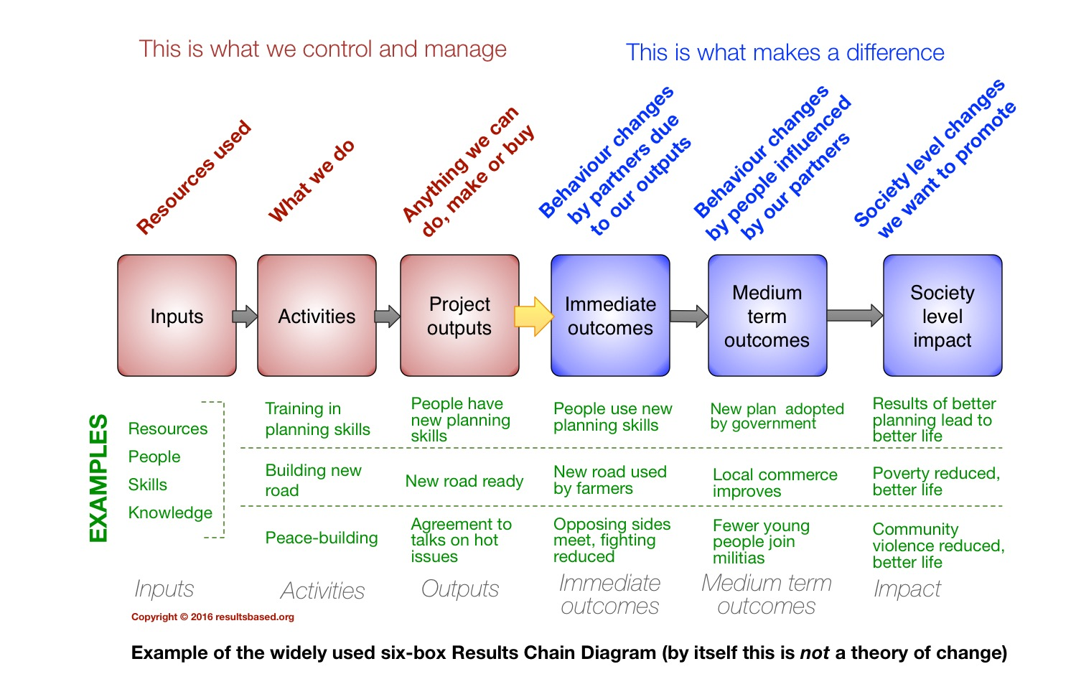

The results chain is a description of the various stages of an intervention that lead to the changes that are intended – from the inputs at the start, to the end effects at a societal level for the beneficiaries. The results chain is often drawn as a series of five or six boxes, as shown above.

The first three links in the chain are under the control of the implementer and present no major issues for monitoring and quality management.

(a) Inputs: Funding, staff, vehicles, etc. Easily monitored by administrative, accounting and audit procedures.

(b) Activities: What the intervention does. Easy to monitor by standard record keeping of activities.

(c) Outputs: Anything that we make, do or buy as a result of inputs and activities. The output of landmine clearance is safe land, the output of a training session is people with more skills and knowledge, the output of risk education is people with more knowledge about safe behavior. Outputs are often straightforward for monitoring and QM.

The last three links of the chain are what the donor, implementer and/or beneficiaries want to achieve. They are less and less under the control of the implementer as we move along the chain, and more difficult for monitoring and quality management. These results links are all based on behavior change where the definition of “behavior” also includes attitudes and decision making.

(d) Immediate outcomes: Behavior changes by people other than the donor and implementer, usually a direct result of the outputs. Usually behaviour change by people who are stakeholders. The outcome of landmine clearance is when cleared land is used productively (a behavior change from avoiding the land due to mines to making use of the land), the outcome of training is when people who have been trained start to use their new skills and knowledge, the outcome of risk education is when people demonstrate reduced risk behavior in their everyday lives.

(e) Medium-term outcomes or intermediate outcomes: Downstream behavior changes by people who have little or no direct involvement in the intervention. Measurement and QM of medium-term outcomes can present challenges. One medium-term outcome of land that has been cleared of mines and then used for agriculture is increased food supply within the community. People not directly involved in the project may benefit if there is more food available in the local marketplace. A medium-term outcome of training people how to develop better plans is when the better plans are adopted and implemented, a medium-term outcome of risk education is when people who did not attend the sessions adopt safe behavior because they see and learn from the safe behavior of friends, neighbours and family members who received training.

(f) Impacts: Usually defined as societal-level changes (rather than individual changes) that eventually result from an intervention, and can include both direct and indirect effects as well as both positive and negative effects (this is a very similar definition to the way “impacts” is defined in evaluation criteria). Improved nutritional status of children in a village may be the long-term result of clearing mines from farmland, this improvement may happen more quickly if more people get their land cleared sooner due to the impact of better planning. Measuring impacts is difficult, and requires a long-term commitment beyond the end of the project for the effects to be realized. Very few interventions make any real provision to continue learning after the end of a project and instead it is common to incorrectly label a few immediate outcomes as impacts in order to supply data. Impacts frequently fall into four broad categories: health (including nutrition, etc.), wealth (economic benefits of any type), wellbeing (social, educational, emotional) and compliance with legal or political commitments (e.g. a national poverty reduction strategy, the Anti-personnel Mine Ban Convention).

The results chain is a highly simplified, linearized view of a complex social process and is not suitable for interventions that are fully within the “complex domain”. Simplification is necessary to make planning possible. The key step is the link between outcome and outputs. This model is suited to linear or ordered systems (see Cynefin framework) and even though it is often used in complex environments, the lack of evident cause and effect in complex adaptive systems means that it is not really suitable.

What are Theories of Change?

What, exactly, are theories of change? It’s not intended as a trick question, but the wide range of views about theories of change causes a lot of problems. Despite conferences about theories of change, and a lot of academic literature, there is still no agreement on a single definition. Funders and implementers often require a project or programme to include a “theory of change” in planning, reporting or evaluation – but then expect their own specific version to be used. What should be a valuable tool that helps everyone to understand a programme or project too often becomes merely a chore when finishing the paperwork.

Summary of this article:

In a project, or programme, or any other intervention:

– a work-plan describes how results are to be achieved – it describes the actions and outputs that will lead to the results;

– a theory of change describes why it is expected that the actions and outputs will lead to the results.

In an ordered (or linear) situation a cause-and-effect type of theory of change is suitable, based on “if this – then that” relationships from the inputs through to the impacts.

In a complex adaptive situation, cause and effect are not repeatable and a theory of change based on people, process, participation and learning must be used. Adaptability is crucial, and adaptive programming provides one of several ways to address the complex domain.

The current discussion between proponents of different approaches to defining theories of change is, essentially, about knowing if the intervention is based in a chaotic, complex, or ordered context. Sense-making frameworks like the Cynefin framework provide a way to understand this and choose the right response for each situation.

Theories of change describe why a project or programme is expected to lead to a change from the current situation to something that is in some way “better”. There is nothing new about theories of change which have been used for about 50 years and are currently facing a resurgence of interest. Sometimes we know exactly where we want to end up, even before starting an intervention. But at other times we can do no more than describe the direction that we need to go, and then move gradually in the right direction to get closer a distant goal that may take many years to achieve. One example of this is when working in peacebuilding in complex situations. Trying to repeat what worked previously, or what worked in a different place may simply fail. In other situations repeating what is known to work may provide useful “good practice” to guide the work (e.g. installing a drinking water system in a town). The context is crucial to success.

To repeat the summary (above):

A work-plan describes how results are to be achieved by undertaking activities.

A theory of change describes why the required results are expected be achieved by the proposed actions and the outputs from the actions.

If we compare an intervention (a project or programme) to a journey, then a theory of change can be like a map, or like a compass bearing, or a set of turn-by-turn instructions, or even guidance as to who to ask in order to discover the route. There is no single answer. Nor is there a single way to share and explain the answer: a written document, a diagram or a map with – or without – notes, or a framework, are the common forms, but there are no restrictions. The flexibility makes theories of change a very powerful tool, but can cause a lot of confusion. To be useful, a theory of change must communicate understanding about why the intervention is expected to succeed.

Current definitions of theories of change often fall into one of the two main groups, summarised below. In practice there is now a chasm between two incompatible approaches. The different views are deeply held, and field staff may be told that they “must provide a theory of change for their work” without explanation of which version to use.

To understand “linear” theories of change it is useful to know about the widely used “results chain diagram”. This is often mistakenly called a theory of change, adding to the confusion. A results chain diagram is not a theory of change – it describes the sequence by which results will be achieved in an ordered or linear intervention, and is not relevant for a complex intervention.

For an in-depth look at theories of change the report by Isabel Vogel for DFID in 2012 gives a lot of information.

sixboxrcd

The two views of theories of change

The first view is that a theory of change comprises the cause and effect links that join the different results of an intervention, as well as the key assumptions.

This is a logical “if this – then that” description that moves along the results chain forwards, or describes what is needed from the previous stage of the results chain to enable progress.

A proponent of this approach is IRC who have made available on-line tools for the humanitarian sector. There are numerous other documents and “how to” guides published for this approach.

An example of this type of theory of change is when an agency runs a workshop to teach planning skills. The theory of change might include either:

Forwards:

IF we train people to plan THEN their planning skills will improve.

IF people have better skills THEN they will write better plans.
Reverse:

IF we want better plans THEN we need people with good planning skills.

IF people are to have better skills THEN training is required.

The reverse approach is preferred as it starts with the outcomes that are wanted, not the activities. In practice, a lot of interventions are planned by starting with the inputs.

To turn the results chain into a theory of change for a linear intervention the key assumptions that underlie the “if-then” logic must also be included. For example:

Assumption example 1: People will stay in their job after they are trained so that they use the new skills. If people leave the organisation immediately after finishing the training then there will be Outputs but no link to Outcomes.

Assumption example 2: There is sufficient political will to allow changes to the way planning is done. Better plans being produced is an Outcome, but if the plans are rejected by the government there is no link to an Impact.

The second view of theories of change is that change is about people, process, participation, and learning. Learning what works in a particular situation is at the core, and those who are involved in the change process are both the key actors in bringing about change as well as the people who are affected by the changes. Flexibility in implementation, based on continual learning, is essential as the situation part-way through the intended change will already be different to the situation at the start, and participants may have changed their views.

A leading proponent of this second approach is the UK Overseas Development Institute (ODI), with a guide by Craig Valters.

Four principles are set out in the ODI guide.
•Focus on process
•Prioritise learning
•Be locally led
•Think compass, not map.

This second view of theories of change is not logic-based. Adapting a theory of change based on process, people, participation and flexible learning, in order to make it match existing administrative and financial structures, that are designed for linear cause-and-effect, can be a challenge. When logframes are used as a planning tool frustration is a common experience. Defining an end-point that has to be reached, or clearly identifying “value for money” may not be feasible, especially in advance of starting work. More relevant measures may involve how much, and in what way the beneficiary community values the Impact of the intervention in their daily lives.

One way that this has been partially addressed is to use adaptive programming to provide a responsive linear model that more closely matches the complex issues.

However, matching the legacy of linear administration and finance to complex interventions in the short term is an imperfect fix and not a long-term solution.

How to reconcile the two opposing views ?

Once the difference between Complicated and Complex is clear, the two views both make sense and can be used as appropriate.

In everyday language, complicated and complex have almost the same meaning. However, just like Inputs, Outputs, Outcomes, have specific meanings for the results chain, Complex and Complicated also have specific definitions for Complexity Thinking. From a complexity viewpoint, there are three types of “system” (or “situation” or “intervention” or “context” or “domain”): (1) ordered or linear, (2) complex, and (3) chaotic. The rough equivalent in physics is solids, liquids and gases.

(1) In an ordered system cause and effect are linked, repeating the same actions leads to the same results each time, and the end goal and the route to get there can be set out before starting. Ordered systems can be divided into obvious systems where the cause and effect are obvious to most people, and complicated systems where cause and effect are still linked and repeatable, but it takes expertise and analysis to make the link.

Fetching a bucket of water is an obvious system. Find the bucket and the tap (faucet), put the bucket under the tap, turn on tap, wait until bucket is full, turn off tap. No need to analyse further. The series of actions is sense-categorise-respond: identify what is going on, select the best known solution, and apply it. For “obvious systems” there is often a single best solution that has been developed over years of experience, which can be described as “best practice”.

Installing a water supply system is (usually) in the complicated ordered domain. Cause and effect still dominate, but specific expertise is now also required: analysis of the hydrology, calculation of demand, slope, access, etc. Previous experience is still a good guide and – within constraints that can be accurately measured – the same basic solution can be repeated for different locations. The series of actions is sense-analyse-respond: identify what is going on, use expertise to make an analysis, and then apply the solution. There are usually multiple possible solutions based on knowledge and analysis so “good practice” is the guide (not “best practice”), and people with expertise will be part of the solution. But, this is still an ordered situation so linear cause and effect still applies and we can plan where we want to end up, and how to get there, before starting. A water supply system can usually be designed, budgeted and planned before starting work, and if the necessary skills and materials are available the plans can be realised on time and on budget.

An example: while filling a bucket with water, the tap breaks and can’t be closed; our “obvious” system just became “complicated”. Expertise will be needed (a plumber who knows how to fix or replace the tap) and there is more than one possible good response: find the main valve and turn it off, or jam something in the end of the pipe to stop the water flow, or if it is an outside tap, use the flow to water the garden until the plumber arrives.

The linear model of a theory of change that uses cause and effect is suitable for either an obvious or a complicated ordered project.

(2) In a complex situation repeating the same action does not get the same results each time. Cause and effect may be visible with hindsight but cannot be seen in advance. The full name for such a system is a “complex adaptive system” – any intervention changes the situation and affects the response. One well known example is the stock market: buying shares today and buying the same shares next year may produce widely different results. The cause and effect of the stock market crash of 2008 is now understood with hindsight, but very few people were able to predict it. Many humanitarian and development interventions, as well as a lot of peacebuilding actions, operate in complex environments. Linear cause and effect don’t apply – though all too often the planning and administration tools of donors (and implementers) rely on linear cause and effect. Clearly, in a complex situation the second type of theory of change that is based on people, process, participation, and learning is more appropriate. A description of the long term aim may not be helpful when starting out, it may be too distant and abstract. For example, peacebuilding that relies on defining an ideal situation where violent conflict no longer takes place and then trying to somehow reach that state, is generally less useful than identifying small moves towards a slightly better situation that can be taken in the short term. Small incremental steps can make an improvement to daily life and also build confidence so that each time the next step seems more feasible. Focussing on the “adjacent possible” rather than “long term impact” often works better in complex interventions. Because repeating an action may produce a different result each time, interventions can’t be replicated directly. Instead, small-scale probes are needed to find out what the reaction will be, and then a larger response can be used to build up actions that produced positive results. If the results of the quick probe are negative, then change course and damp-down the unwanted results. The theory of change can be described in terms of a compass direction for the next step, but not in terms of a distant (and theoretical) end-point that may never be reached.

The required sequence of actions for a complex situation is probe-sense-respond: find out what brings the adaptive situation to a better nearby state, build on that positive response to take a step in the right direction, then repeat the probe. If a probe produces unintended negative consequences it is not a failure, but an important lesson in what to avoid. Learning about what doesn’t work in a given situation is part of building success.

(3) In a truly chaotic situation there is no pattern of events, nothing can be predicted and the over-riding need is to bring about sufficient order to start to move away from chaos. Rapid response is needed, and the sequence becomes: act-sense-respond. Immediately steering the chaotic towards an increase in order is of more value than focussing on a longer term ideal. Failure to respond in time to chaos can lead to human suffering and death, or serve as a driver for extremism.

A useful sense-making framework that clearly sets out the obvious, complicated, complex, chaotic and disordered is the Cynefin framework – there is more information on this page.

Adaptive programming for complex interventions.

Adaptive programming and adaptive implementation are ways of addressing the issue of how to work, in practical terms, in complex interventions. Duncan Green’s blog post here gives an introduction and some useful links to DFID work. The adaptive “shopping list” for how to implement includes:

“adaptive, iterative, flexible, problem driven, politically smart and locally led”.

This is a useful approach with a lot of practical applications, but in many ways represents a users’ guide for “how to successfully hammer a square (linear) peg into a round (complex) hole”. In practice, this may be the best that can be done if funding and administration is locked to a “cause and effect” model that pretends all situations are predictable. Adaptive programming may be pragmatic, and it includes political and power issues which are crucial, but it risks spending a lot of effort to rediscover, through extensive field work, what is already well known and understood through formal complexity thinking. Complexity thinking is already used in other areas of work like complex computer software development; the humanitarian/development/peacebuilding sector does not need to reinvent the wheel when it can learn from the success of others. Setting aside what is already known and well documented and starting to rediscover complexity thinking by experimenting with new ways of “adaptive implementation” is likely to be a slow, difficult and costly route.

Conclusion.

The value of a theory of change comes from increasing understanding (by participants, beneficiaries, donors, and the general public) about why it is expected that the chosen intervention will produce the desired results – the workplan describes how the activities and outputs will achieve the results.

There is no single form of a theory of change that has universal application. The two main versions: linear cause and effect, and the people, process, participation and learning model, each has application in a separate context. Complexity thinking describes these contexts as “ordered”, and “complex adaptive” domains, respectively. There is not yet a widely used theory of change model for the chaotic domain, experienced field practitioners are needed to lead the response to chaos as acting to reduce the chaos is the first step.

The two different theory of change approaches have been presented as a disagreement, and no single unifying model has been agreed. However, there is no point in arguing about the symptoms (incompatible views about theories of change) until we understand the root causes (the need for different responses to: complex environments, complicated but ordered environments, and chaotic environments). Once the context is understood the whole disagreement about theories of change reduces to deciding which is the context-appropriate method. A single theory of change for all circumstances is not possible, but also not desirable.

The humanitarian, development and peacebuilding sector does not, in general, know about complexity thinking and sense-making frameworks, and this gap in knowledge will continue to limit the value of using theories of change. The frustration (and even anger) that many practitioners feel when forced to use linear tools for a complex domain could be reduced by an understanding of complexity. Fortunately, available on-line resources about sense-making frameworks like the Cynefin framework are readily available, they are well established in other complex domains, and their use in humanitarian interventions, development and peacebuilding is increasing.

A more difficult challenge is the implementation of a probe-sense-respond complexity sequence when funding comes from traditional donors who insist on working only with linear cause and effect tools. The compromise of “adaptive programming” is pragmatic, but relies heavily on the insight and determination of individual project leadership.

Russell Gasser resultsbased.org September 2016.

Logframes

The origin of the logframe

The origin of the logical framework or logframe is usually credited to the report “Project Evaluation and the Project Appraisal Reporting System” published in July 1970. The report was commissioned by USAID and written by Rosenberg, Posner, and Hanley of Fry Consultants. A scan of a used copy of the report is still available for download from the USAID website: Vol 1, summary, Vol 2 Findings, Vol 3 Implementation. The report is typed, not written on a word processor, as it was published eleven years before the first IBM personal computer was available. Logframes do not depend on computers and spreadsheets.

USAID wanted to evaluate and compare the results of work they were funding in different parts of the world, and had proposed a Project Appraisal Report (PAR) system. The PAR system was widely disliked in the field and not functioning. The consultant team found that reporting varied so much that any inter-regional comparison would be difficult, if not impossible. Even more important they found that the available reporting was based on resources used and activities undertaken, and made little or no mention of any results, nor of the reasons why projects had been funded and implemented. In the middle of the inside front cover of the final report, they wrote a single sentence, using the largest size font available on the electric typewriter:

“If you don’t know where you’re going, any road will get you there.”

This is a boldly critical opening statement for a major report to USAID – it is a paraphrase (and not actually a quote) from Lewis Carroll’s “Alice’s adventures in Wonderland”.

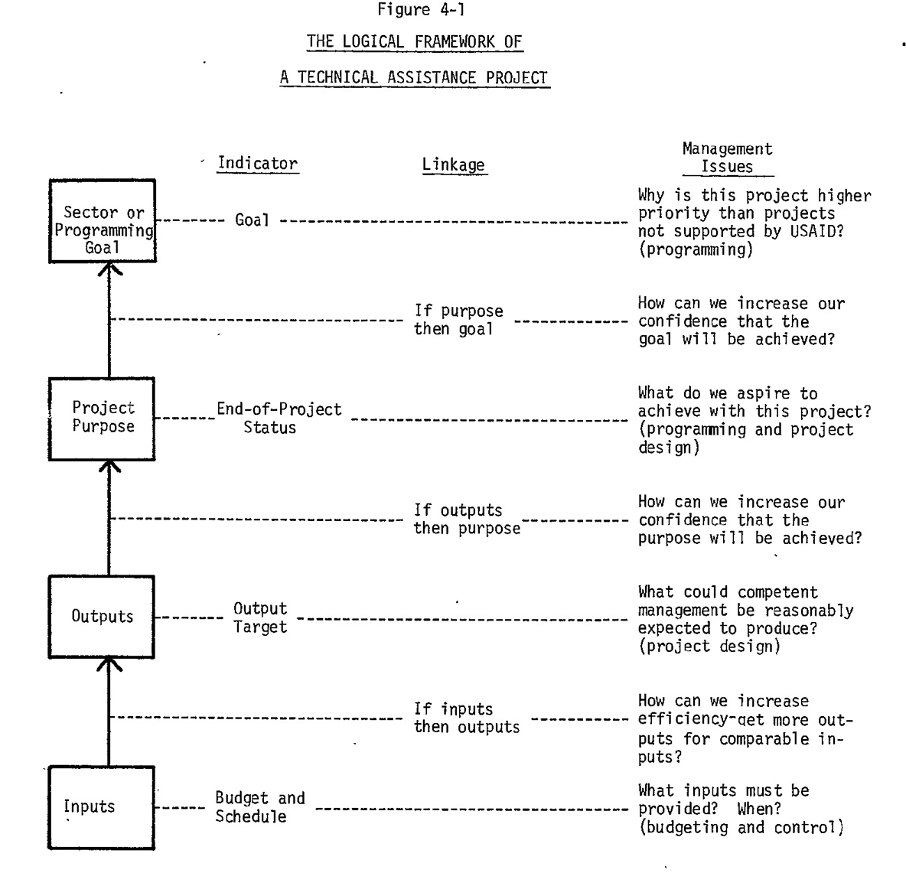

The consultant team proposed a results-based reporting format, shown above, to be used by all projects, field tested a prototype in one region, and then refined it and applied it elsewhere. Although the terminology has changed a little, the format they proposed is the log frame, with an additional column for what would today be called the cause-effect links of a theory of change of the project (they call it “Linkage”). The original layout does not include the source of information for indicators.

In part 1 of the report, TITLE (link1 above), the team note, page II-2,
“Our operating assumption was that, for each mission visited, there was a mission-useful evaluation process that predated the PAR requirement and with which PAR preparation was to at least some extent redundant. […]

Contrary to our operating assumption, our finding was that prior to imposition of the PAR requirement there was no systematic evaluation process in place at any mission we visited. ［…] in particular, the issue of project significance was very rarely raised in an actionable framework – that is, raised in such a way as to imply appropriate replanning activities or actions.”
“Significance” would now be called “relevance” in the OECD DAC guidelines.

What is the logframe for ?

The prototype log frame copied above is figure 4-1 on page IV-4 of the introduction section of the Fry consulting report. Nearly 50 years later, with only a few small changes to the terminology, it remains what it always has been: a one-page summary that explains why the intervention is being undertaken, why we think that it will produce the desired results, how we will know the results that have been achieved, and the results chain from inputs through to (what is now called) impacts.

The log frame is not and never has been a method in itself; it is a useful way to summarise an intervention on a single sheet. The log frame is not the planning process, but it is a way to summarise clearly and logically the results of the planning process before starting work, and then as the intervention proceeds it needs to be updated to match reality and include the intermediate and final results. The log frame is not reality, it is a summary of what has been planned and achieved. The information in the logframe is not fixed, it is a summary of a changing situation, so requires updating to keep it relevant. For example, once the planning has been done by a suitable planning process involving project partners (a process that generally should be inclusive, gender sensitive, non-discriminatory, etc) the results can be transferred from the planning documents to the log frame, as a convenient way to summarise. Part of the confusion comes from the European commission developing a planning methodology, based on problem tree analysis, and calling it the log frame approach or LFA. The LFA is the methodology, the log frame is the single sheet summary once the planning is complete. All the information included on the logframe is copied there from other documents, such as the indicator definition document, the planning documents, the list of proposed activities, etc, the logframe is not an original source document.

The key limitation of the logframe is that it can only be used in situations where there is repeatable linear cause and effect. For working in the complex domain (see Cynefin framework) the assumption of linear cause and effect is false and other methods should be used.

